Name: __________________________________

Fetch an Item from Your Online Catalog
Practice your search skills with Fetch, INFOhio’s online catalog for students.

Mrs. Smith has assigned a project about animals. To find out more information, you go to your school library and use Fetch to do a simple search for the keyword “animals”. Below is one of the items in your search results. Answer the following questions.

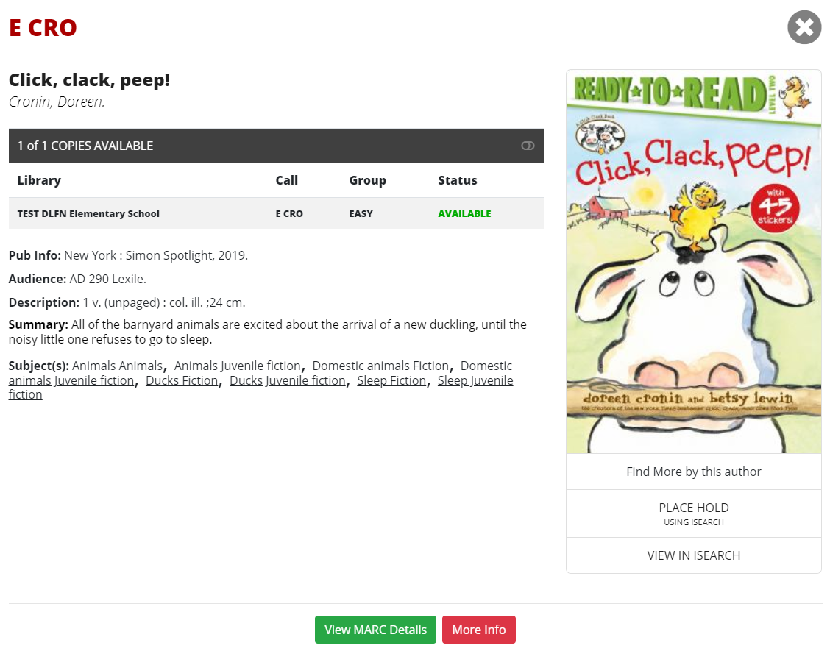

What is the title of the book?
Who is the author?
What is the call number?
In what section of the library would you find this book?
Is this book available to check out?
How many copies of this book does our library have?
What is the Reading Level?
What tells you what the book is about?
What year was this book published?
What kind of search would you do if you wanted to only find nonfiction books about animals?

Answer Key:
- Click, clack, peep!
- Doreen Cronin
- E CRO
- Easy or Everybody section
- Yes
- One
- AD 290 Lexile
- Summary
- 2019
- Advanced Search

